Coding Assessment:

Please create simple CRUD web application using ASP.Net (ASP.net MVC preferred)

the application will contain at least 2 pages

1. List of Contact Person

The page will contain Contract Person List as follow:

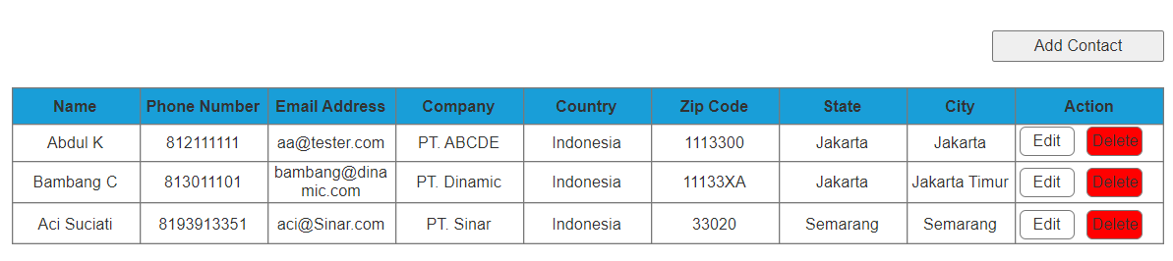

When user click Add Contact and Edit, Form Entry of Contract Person will show

2. Form Entry for Add and Delete Contract Person as follow:

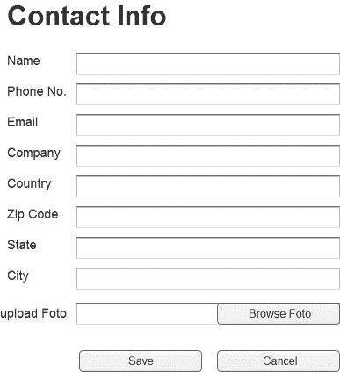

*Please use client validation to prevent Error

Your solution should be available for review on **github**

Please Reply Our Email by sending us your github link of your solution